Seeing the doctor just got easier!

Sometimes you just can’t get to the doctor’s office when you’re sick. Now you can enjoy the convenience of seeing a board-certified doctor right from your phone or computer.
And right now is a really good time to get yourself set up with Doctors Online.
Why? Because entering your details now saves time when you actually need an appointment with one of our online doctors.
The only thing left to do is see the doctor!

How do I sign up?
Creating an account is easy.
- Search “BCBSRI Drs. Online” from the Apple or Google app store*, or visit
drs-online.com.
- Have your BCBSRI ID card handy.
- See the next available doctor or make an appointment.

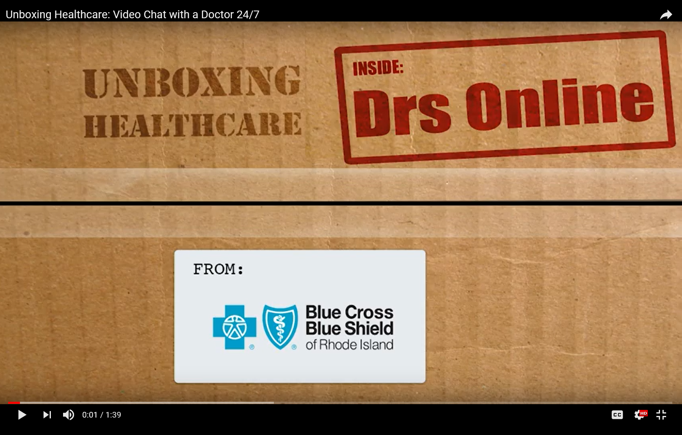
Check out this video to learn more.

* Standard mobile phone carrier and data usage charges apply. The downloading and use of the Your Blue Touch mobile app is subject to the terms and conditions of the app and the online stores from which it is downloaded. Apple and the Apple logo are trademarks or Apple Inc., registered in the U.S. and other countries. App Store is a service mark of Apple Inc. Google Play is a trademark of Google Inc.
In the case of an emergency, you should always call 911 or your local emergency services. Doctors Online is not intended to replace these services and should not be used in those circumstances.
Doctors Online is a telemedicine service provided by American Well®, an independent company that administers Doctors Online on behalf of Blue Cross & Blue Shield of Rhode Island.
Blue Cross & Blue Shield of Rhode Island is an independent licensee of the Blue Cross and Blue Shield Association.

