Join a gym – or 10,000 gyms – for only $29!

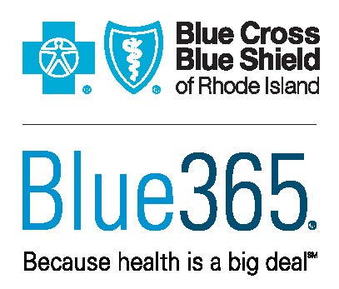
Find great discounts on gyms, nutrition services, sneakers, fitness trackers, and more. They’re all in Blue365—available at no cost through your Blue Cross & Blue Shield of Rhode Island (BCBSRI) plan.*
Register now at blue365deals.com to take advantage of deals from more than 45 national brands, exclusively for our members.

And that $29 a month gym membership? It’s good at 10,000 gyms, so you can hop from one to another.

Just have your BCBSRI member ID card handy. In a couple of minutes, you will be registered and ready to shop.

Questions? We’re happy to help! Give us a call at (401) 459-5000 or 1-800-639-2227, or visit any of our three Your Blue StoreSM locations.

* These services are available to Blue Cross & Blue Shield of Rhode Island members only.

The Blue365 program is made available by BCBSRI in conjunction with the Blue Cross and Blue Shield Association. The Blue Cross and Blue Shield Association is an association of independent, locally operated Blue Cross and/or Blue Shield Companies. Blue365 offers access to savings on health and wellness products and services and other interesting items that Members may purchase from independent vendors, which are not covered benefits under your policies with BCBSRI, its contracts with Medicare, or any other applicable federal healthcare program. These products and services will be offered to you through the entire benefit year. During the year, the independent vendors may offer additional discounts on these products and services. To find out what is covered under your policies, contact BCBSRI. The products and services described on the Site are neither offered nor guaranteed under BCBSRI’s contract with the Medicare program. In addition, they are not subject to the Medicare appeals process. Any disputes regarding your health insurance products and services may be subject to your Blue Company’s grievance process. BCBSA may receive payments from vendors providing products and services on or accessible through the Site. Neither BCBSA nor BCBSRI recommends, endorses, warrants, or guarantees any specific vendor, product or service available under or through the Blue365 Program or Site.
Blue Cross & Blue Shield of Rhode Island is an independent licensee of the Blue Cross and Blue Shield Association.

