Are you connected?

Are you connected with Blue Cross & Blue Shield of Rhode Island on your mobile devices?*

You’ve got two great tools to help you stay connected to your health plan anywhere you are:

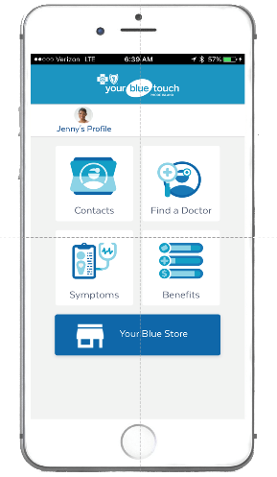
- Mobile app – View your plan information and benefits right from the palm of your hand Your Blue Touch RI. Just download it from the App Store or Google play.** Then click on the “sign up” link and follow the prompts. Be sure to enter your name and member ID exactly as they appear on your BCBSRI member ID card.
- Secure messaging service – Choose Your Blue Wire RI to receive secure, personalized messages about your health and health plan right on your phone or device. You’ll get important reminders, money-saving tips, and more. Sign up by texting “BCBSRI” to 73529 or calling 1-844-779-8820.

Questions? We’re happy to help! Give us a call at (401) 459-5000 or 1-800-639-2227, or visit any of our three Your Blue StoreSM locations.

Information provided in Your Blue Touch RI about your benefits is only a summary and not a contract. Other exceptions, reductions and limitations may also apply to your benefits. For details about coverage, please see the subscriber agreement for the plan or contact the plan directly. This tool is not intended to be a substitute for medical care provided by a physician. It is for educational purposes only and does not provide medical advice.

Your Blue Wire is subject to the terms and conditions of the messaging service.

* These services are available to Blue Cross & Blue Shield of Rhode Island members only.
** Standard mobile phone carrier and data usage charges apply. The downloading and use of the Your Blue Touch mobile app is subject to the terms and conditions of the app and the online stores from which it is downloaded. Apple and the Apple logo are trademarks or Apple Inc., registered in the U.S. and other countries. App Store is a service mark of Apple Inc. Google Play is a trademark of Google Inc.

Blue Cross & Blue Shield of Rhode Island is an independent licensee of the Blue Cross and Blue Shield Association.

