Did you eat too much?

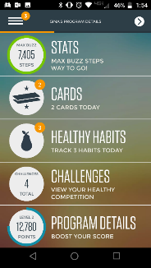
The holidays are over, and it’s time to start eating right! Start with a healthy habit: “Did you check how many servings are in your food today?”

Start an “Over Served” challenge and invite your coworkers!*

Open your Virgin Pulse® app and tap “challenges” then “create healthy habit challenge.” Tap “Over Served” to start it up and invite players. (Be sure you’ve chosen “Eating Healthy” under My Interests so you can see Over Served.)

View step-by-step instructions.

Haven’t downloaded the Virgin Pulse app yet? It’s easy!
3 simple steps to get started!
1. Sign up – Go to join.VirginPulse.com or download the Virgin Pulse app at the Apple App Store or Google Play.**
2. Choose Blue Cross & Blue Shield of Rhode Island as your sponsor.
3. You can also connect your Fitbit® or other wearable device to track and sync steps with the app.
Now get tracking!
* This program is available to Blue Cross & Blue Shield of Rhode Island members only. The program is entirely optional, and does not impact benefits under the Blue Cross & Blue Shield of Rhode Island health plan.
** Standard mobile phone carrier and data usage charges apply. The downloading and use of the Virgin Pulse mobile app is subject to the terms and conditions of the app and the online stores from which it is downloaded. Apple and the Apple logo are trademarks or Apple Inc., registered in the U.S. and other countries. App Store is a service mark of Apple Inc. Google Play is a trademark of Google Inc.
Virgin Pulse® is an independent wellness company, contracted by Blue Cross & Blue Shield of Rhode Island to provide wellness services.
Blue Cross & Blue Shield of Rhode Island is an independent licensee of the Blue Cross and Blue Shield Association.

