Get healthy, get rewards

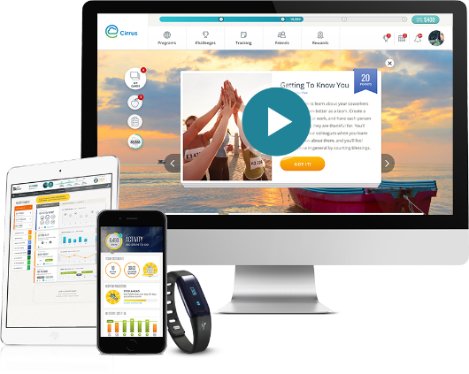
It’s time to get started with your well-being program!*

The Blue Cross & Blue Shield of Rhode Island program,
powered by Virgin Pulse®, can help you reach your
health goals and earn rewards along the way.
It’s easy, it’s fun, and it’s a great way to get (or stay!)
inspired to eat well, sleep better, get more active,
manage your stress, and more!

Virgin Pulse lets you:
- Set your goals and interests
- Register and connect your Fitbit® or other device to help you get points and rewards faster
- Track your activities, like walking and even drinking more water
- Track your weight and blood pressure
- Join fun challenges with others

3 Simple steps to get started!
1. Sign up – Go to join.VirginPulse.com or download the Virgin Pulse app at the Apple App Store or Google Play.**
2. Choose Blue Cross & Blue Shield of Rhode Island as your sponsor.
3. You can also connect your Fitbit® or other wearable device to track and sync steps with the app.
Watch how quick it is to register.
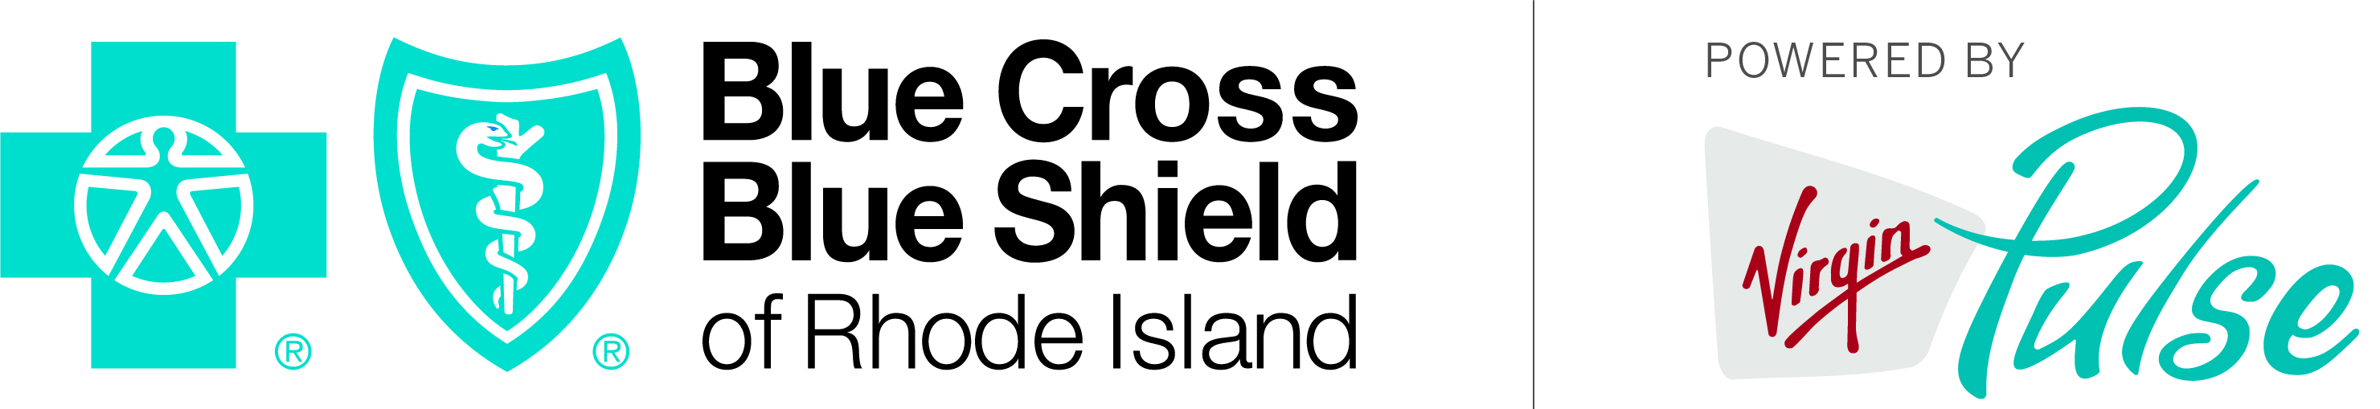Now get tracking!
* This program is available to Blue Cross & Blue Shield of Rhode Island members only. The program is entirely optional, and does not impact benefits under the Blue Cross & Blue Shield of Rhode Island health plan.
** Standard mobile phone carrier and data usage charges apply. The downloading and use of the Virgin Pulse mobile app is subject to the terms and conditions of the app and the online stores from which it is downloaded. Apple and the Apple logo are trademarks or Apple Inc., registered in the U.S. and other countries. App Store is a service mark of Apple Inc. Google Play is a trademark of Google Inc.
Virgin Pulse® is an independent wellness company, contracted by Blue Cross & Blue Shield of Rhode Island to provide wellness services.
Blue Cross & Blue Shield of Rhode Island is an independent licensee of the Blue Cross and Blue Shield Association.

